**AUTOSAGE APP USING GEMINI FLASH**

**1. INTRODUCTION**

**1.1. Project Overview**

**Project Title: Autosage App Using Gemini Flash**

**Team Id: LTVIP2026TMIDS73327**

**Team Members:**

* Poojitha Kanipakam – Team Leader
* U. Lavanya – Team Member
* K. Parimala – Team Member
* Vallepu Prashanth Kumar – Team Member

AutoSage is an AI-powered application that provides detailed information about two-wheeler and four-wheeler vehicles using image-based analysis. The system uses Google’s Gemini Flash model to analyze vehicle images and generate structured details such as brand, model, mileage, price range, and resale value. AutoSage simplifies the vehicle selection process by delivering real-time insights through an easy-to-use Streamlit interface.

* **Scenario 1: Buying a New Motorcycle**  
  Sarah uses AutoSage to compare motorcycle specifications, features, and prices within her budget, helping her make an informed purchase decision.
* **Scenario 2: Vehicle Maintenance Tips**  
  AutoSage provides seasonal maintenance suggestions, such as checking tire pressure and battery health, to help users maintain vehicle safety and performance.
* **Scenario 3: Finding Eco-Friendly Vehicles**  
  Emma uses AutoSage to explore electric and hybrid vehicles by understanding efficiency, environmental impact, and available incentives.

**1.2. Purpose**

The primary purpose of the **AutoSage project** is to develop an intelligent Generative AI–based system that can automatically analyse vehicle images and provide detailed vehicle information. It aims to assist users such as vehicle buyers, owners, and eco-conscious consumers by enabling quick and accurate understanding of two-wheeler and four-wheeler details reducing manual research and improving decision-making efficiency.

**Key Objectives:**

* To analyse vehicle images using a multimodal Generative AI model.
* To generate structured vehicle details such as brand, model, mileage, price and resale value.
* To build a simple user-friendly web application using Streamlit.
* To enable real-time vehicle comparison and information retrieval for practical use cases.

**2. IDEATION PHASE**

**2.1. Customer Problem Statement**

People interested in purchasing or comparing two-wheelers and four-wheelers often struggle to access complete and reliable vehicle information from a single source. Important details such as manufacturer, model, mileage, key features, price range, and resale value are scattered across different platforms. Users are forced to manually search and analyze lengthy technical descriptions, which consumes time and creates confusion. Most existing solutions do not leverage image-based artificial intelligence to deliver quick and well-organized insights. As a result, users experience uncertainty and lack confidence while making vehicle-related decisions.

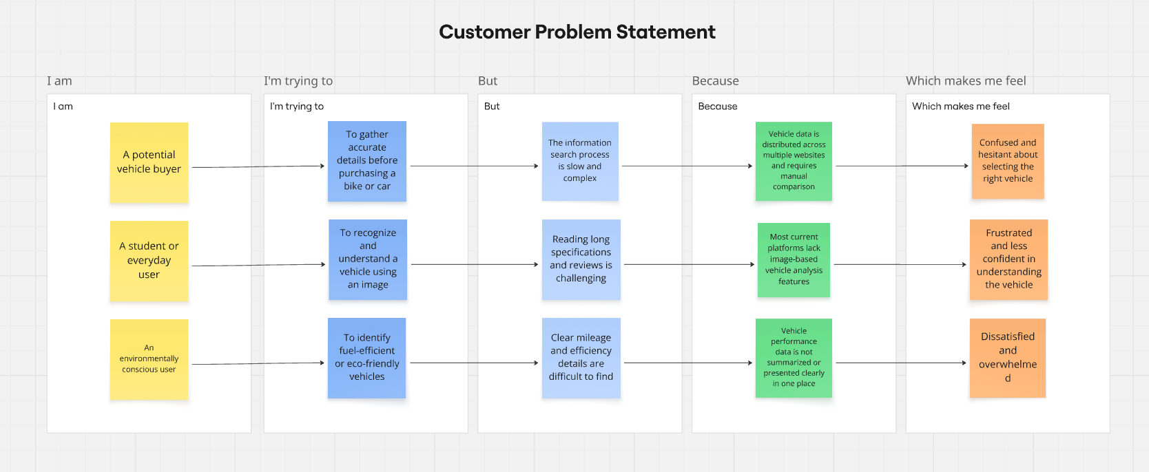**Link:** [**https://miro.com/app/board/uXjVG_OZKgA=/?share_link_id=529701320551**](https://miro.com/app/board/uXjVG_OZKgA=/?share_link_id=529701320551)

|  |  |  |  |  |  |
| --- | --- | --- | --- | --- | --- |
| **Problem**  **Statement (PS)** | **I am**  **(Customer)** | **I’m trying to** | **But** | **Because** | **Which makes me feel** |
| PS-1 | A potential vehicle buyer | To gather accurate details before purchasing a bike or car | The information search process is slow and complex | Vehicle data is distributed across multiple websites and requires manual comparison | Confused and hesitant about selecting the right vehicle |
| PS-2 | A student or everyday user | To recognize and understand a vehicle using an image | Reading long specifications and reviews is challenging | Most current platforms lack image-based vehicle analysis features | Frustrated and less confident in understanding the vehicle |
| PS-3 | An environmentally conscious user | To identify fuel-efficient or eco-friendly vehicles | Clear mileage and efficiency details are difficult to find | Vehicle performance data is not summarized or presented clearly in one place | Dissatisfied and overwhelmed |

**2.2. Empathy Map Canvas**

**Empathy Map Canvas:**

An empathy map is a simple, easy-to-digest visual that captures knowledge about a user’s behaviours and attitudes.

It is a useful tool to helps teams better understand their users.

Creating an effective solution requires understanding the true problem and the person who is experiencing it. The exercise of creating the map helps participants consider things from the user’s perspective along with his or her goals and challenges.

Link: <https://app.mural.co/t/bookorder5979/m/bookorder5979/1771324696037/96a80f7b01422519080c2d42edf649129af38059?sender=u51a81d0fe7f8332550812027>

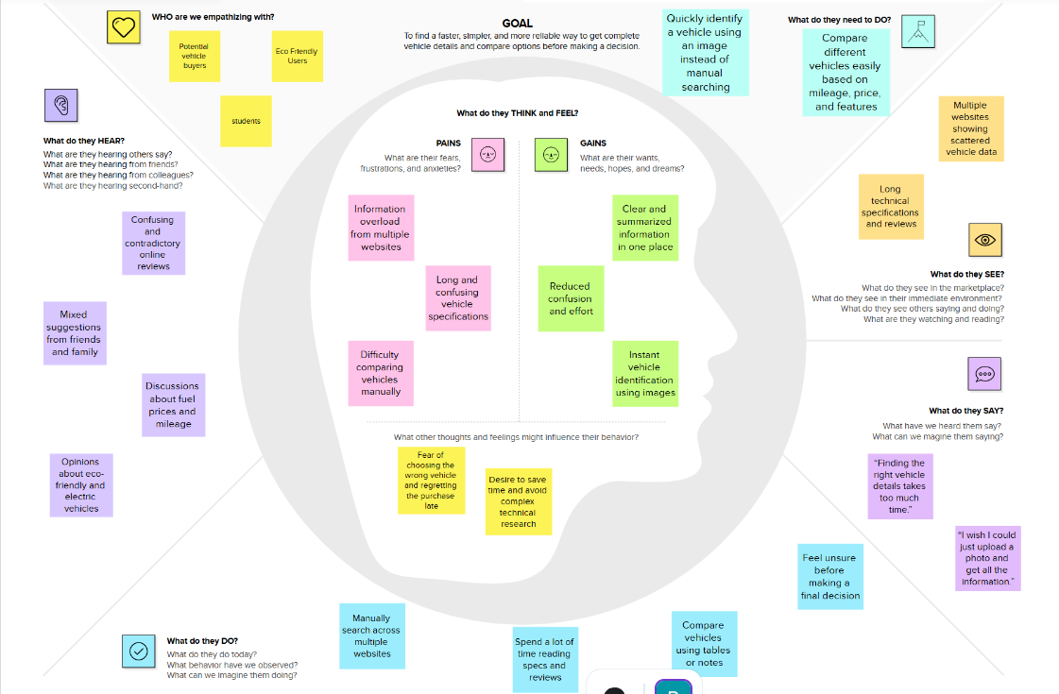

**2.3 Brainstorming**

**Brainstorm & Idea Prioritization:**

Brainstorming provides a free and open environment that encourages everyone within a team to participate in the creative thinking process that leads to problem solving. Prioritizing volume over value, out-of-the-box ideas are welcome and built upon, and all participants are encouraged to collaborate, helping each other develop a rich number of creative solutions.

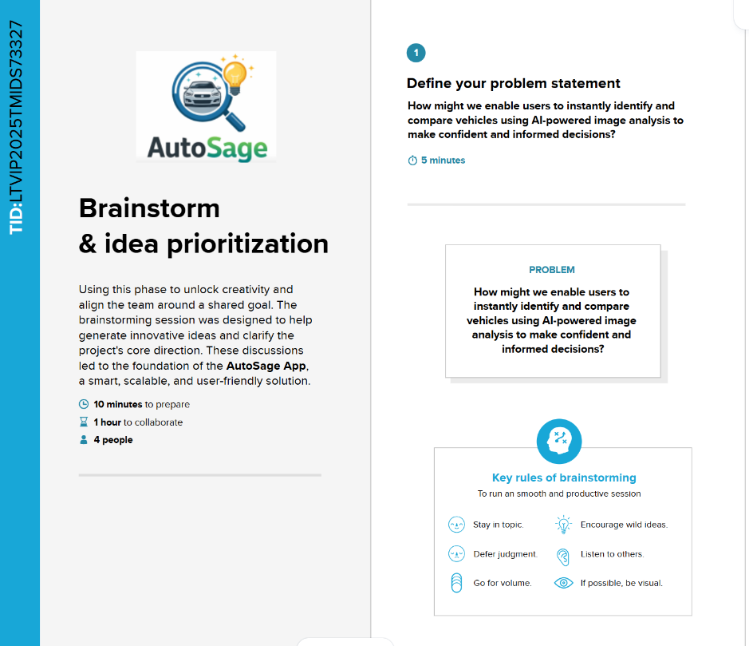**Step-1: Team Gathering, Collaboration and Select the Problem Statement**

Link: <https://app.mural.co/t/bookorder0417/m/bookorder0417/1750771118627/79ec7991466208f26ea8dd22912d5481f0bcf596?sender=u427be78f24cc5d79ea230073>

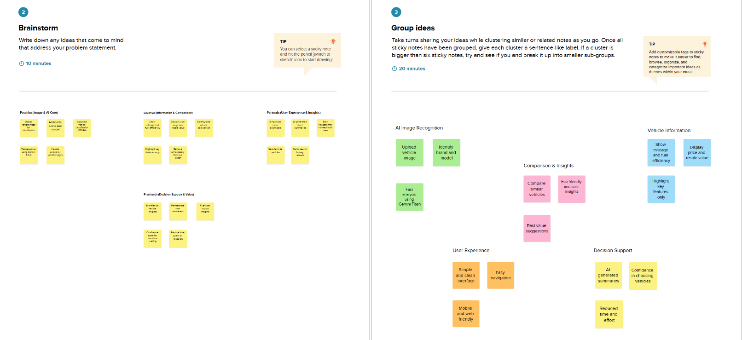**Step-2: Brainstorm, Idea Listing and Grouping**

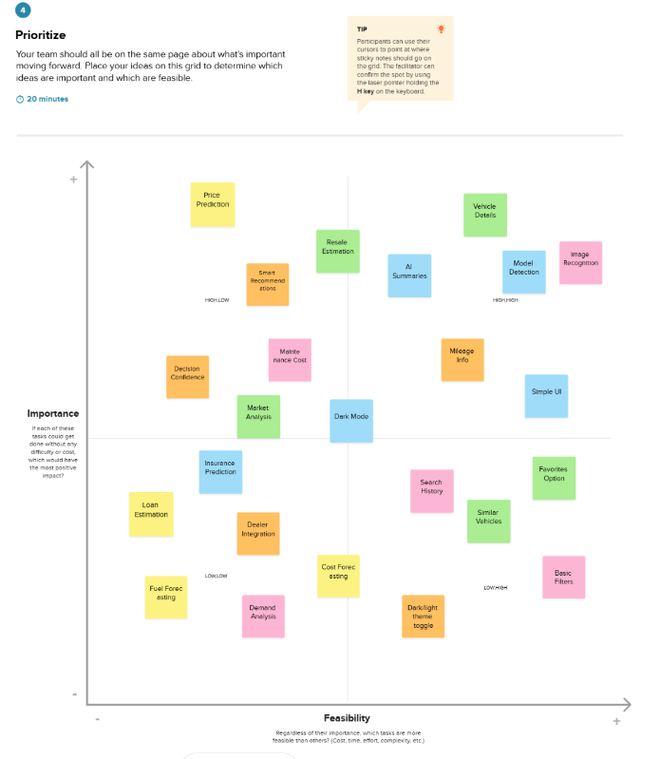**Step-3: Idea Prioritization**

**3. REQUIREMENT ANALYSIS**

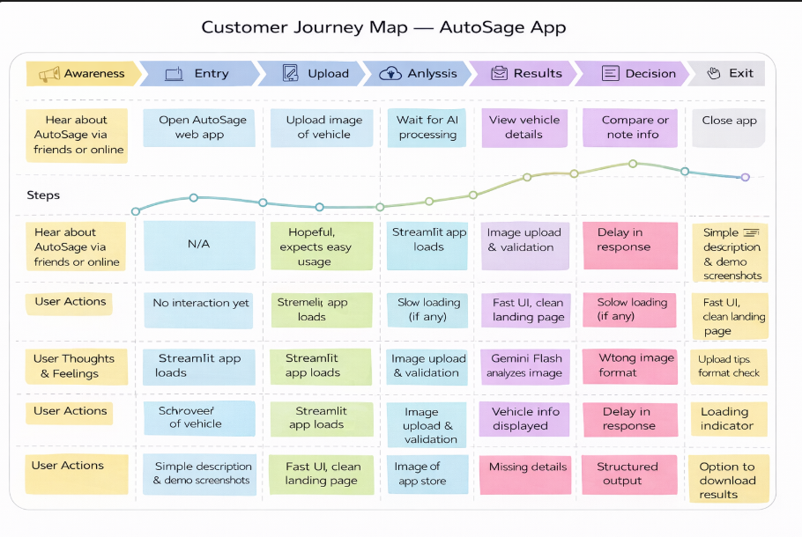**3.1. Customer Journey Map**

**3.2. Solution Requirement**

**Functional Requirements – AutoSage App**

|  |  |  |
| --- | --- | --- |
| **FR No.** | **Functional Requirement (Epic)** | **Sub Requirement (Story / Sub-Task)** |
| **FR-1** | User Interface Access | Launch web application and view home screen |
| **FR-2** | Image Upload | Upload vehicle images in JPG, JPEG, or PNG format |
| **FR-3** | Image Validation | Validate image size and supported formats |
| **FR-4** | AI Image Analysis | Analyze uploaded image using Gemini Flash |
| **FR-5** | Vehicle Identification | Identify vehicle brand and model |
| **FR-6** | Vehicle Information Display | Display mileage, price range, and resale value |
| **FR-7** | AI Summary Generation | Generate clear and structured vehicle insights |
| **FR-8** | Result Presentation | Display results in user-friendly format |
| **FR-9** | Error Handling | Handle invalid images or processing errors |
| **FR-10** | Secure API Usage | Protect API keys using environment variables |

**Non-functional Requirements – AutoSage App**

|  |  |  |
| --- | --- | --- |
| **NFR No.** | **Requirement** | **Description** |
| **NFR-1** | Usability | Interface should be simple and easy to use |
| **NFR-2** | Security | Secure API keys and sensitive data |
| **NFR-3** | Performance | Image processing and results should be fast |
| **NFR-4** | Reliability | System should work consistently without failure |
| **NFR-5** | Availability | Application should be accessible during operation |
| **NFR-6** | Scalability | System should support future user growth |

**3.3. Data Flow Diagram**

**Data Flow Diagrams:**

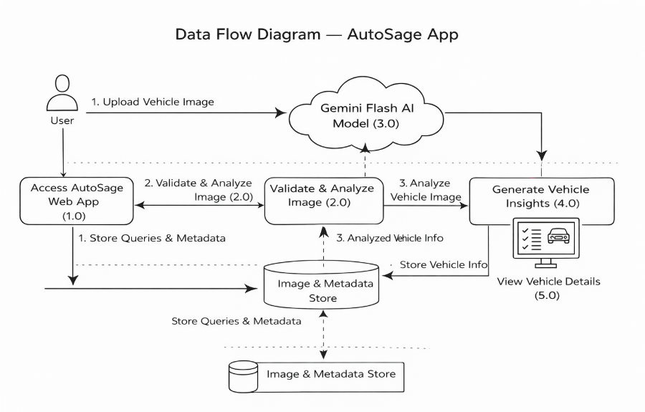A **Data Flow Diagram (DFD)** illustrates how data moves within the Freelance Finder platform. It captures how users (freelancers and clients) interact with the system, how information flows between different components, and where the data is stored.

**User Story Table – AutoSage App**

|  |  |  |  |  |  |
| --- | --- | --- | --- | --- | --- |
| **User Type** | **Functional Requirement (Epic)** | **User Story / Task** | **Acceptance Criteria** | **Priority** | **Release** |
| **User** | App Access | As a user, I can open the AutoSage web application. | Application loads successfully. | High | Sprint-1 |
| **User** | Image Upload | As a user, I can upload a vehicle image. | Image uploads without errors. | High | Sprint-1 |
| **User** | Image Validation | As a user, I want only valid images to be accepted. | Invalid formats are rejected. | High | Sprint-1 |
| **User** | AI Analysis | As a user, I want the system to analyze my vehicle image using AI. | Image is processed successfully. | High | Sprint-1 |
| **User** | Vehicle Identification | As a user, I want to know the vehicle brand and model. | Correct brand and model are displayed. | High | Sprint-1 |
| **User** | Vehicle Details | As a user, I want to see mileage and price details. | Vehicle details are shown clearly. | High | Sprint-1 |
| **User** | Resale Information | As a user, I want to view resale value estimates. | Resale value is displayed. | Medium | Sprint-2 |
| **User** | AI Summary | As a user, I want a short AI-generated summary. | Summary is concise and readable. | Medium | Sprint-2 |
| **User** | Error Handling | As a user, I want clear messages for errors. | Error messages are shown properly. | Medium | Sprint-2 |
| **Admin** | System Monitoring | As an admin, I want to monitor system activity. | Logs are recorded successfully. | Low | Sprint-2 |

**3.4. Technology Stack**

**Technical Architecture:**

**AutoSage** follows a three-tier architecture consisting of a user interface layer, application logic layer, and data/model layer. The application allows users to upload vehicle images, which are processed using Gemini Flash AI to identify vehicles and generate structured insights such as brand, model, mileage, price range, resale value, and eco-efficiency. The system is deployed on cloud infrastructure to ensure scalability, performance, and availability.

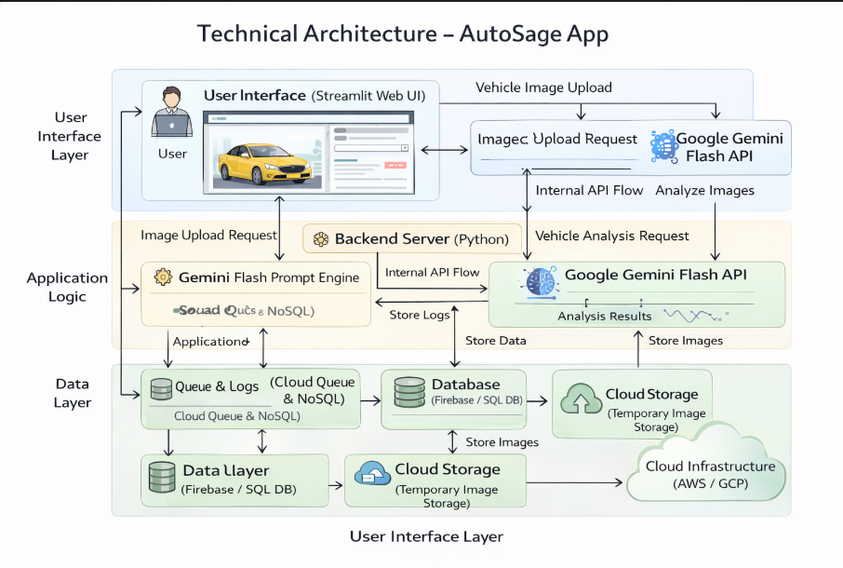

**Table-1: Components & Technologies:**

|  |  |  |  |
| --- | --- | --- | --- |
| **S.No** | **Component** | **Description** | **Technology** |
| **1** | User Interface | Allows users to upload vehicle images and view results | Streamlit Web UI, HTML, CSS |
| **2** | Application Logic – 1 | Handles request processing and application flow | Python |
| **3** | Application Logic – 2 | Processes vehicle image and extracts features | Google Gemini Flash API |
| **4** | Application Logic – 3 | Generates summarized vehicle insights | Gemini Flash Prompt Engine |
| **5** | Database | Stores user queries and vehicle metadata | SQLite / NoSQL |
| **6** | Cloud Database | Cloud-based data storage for scalability | Firebase / Cloud Firestore |
| **7** | File Storage | Temporary storage for uploaded images | Local File System / Cloud Storage |
| **8** | External API – 1 | AI-based image understanding | Google Gemini Flash API |
| **9** | External API – 2 | Vehicle reference and pricing data | Open Vehicle Data APIs |
| **10** | Machine Learning Model | Identifies vehicle and extracts details | Multimodal Vision–Language Model |
| **11** | Infrastructure (Server / Cloud) | Deployment and hosting environment | Local System / AWS / GCP |

**Table-2: Application Characteristics:**

|  |  |  |  |
| --- | --- | --- | --- |
| **S.No** | **Characteristic** | **Description** | **Technology** |
| **1** | Open-Source Frameworks | Frameworks used to build the application | Python, Streamlit |
| **2** | Security Implementations | Secure access and data protection | HTTPS, API Keys, Environment Variables |
| **3** | Scalable Architecture | Supports increased users and data load | Three-Tier Architecture, Cloud Deployment |
| **4** | Availability | Ensures continuous access to application | Cloud Hosting, Distributed Services |
| **5** | Performance | Optimized for fast image analysis and response | Gemini Flash, Lightweight UI, Caching |

**4. PROJECT DESIGN**

**4.1. Problem Solution Fit**

**Problem – Solution Fit Template:**

The Problem-Solution Fit means identifying the real problems faced by vehicle buyers and ensuring that the AutoSage solution effectively addresses those issues using AI-powered vehicle analysis.

**Purpose:**

* Solve vehicle comparison and information access problems efficiently.
* Help users make informed vehicle purchase decisions.
* Provide AI-based insights using Gemini Flash.
* Improve user confidence while selecting vehicles.
* 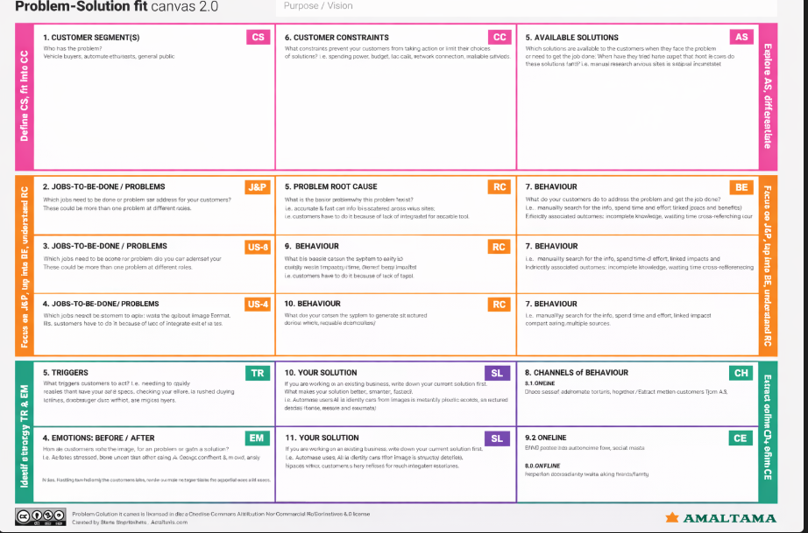Simplify vehicle analysis through image-based processing.

**4.2. Proposed Solution**

**Proposed Solution for AutoSage App**

|  |  |  |
| --- | --- | --- |
| **S. No.** | **Parameter** | **Description** |
| 1 | Problem Statement (Problem to be solved) | Vehicle buyers and general users face difficulty in obtaining complete vehicle information from a single source. Information is scattered across multiple platforms and lacks instant image-based analysis, making decision-making slow and confusing. |
| 2 | Idea / Solution Description | AutoSage is an AI-powered web application that uses the Gemini Flash model to analyze uploaded vehicle images and instantly provide structured details such as brand, model, mileage, price, and resale value through an easy-to-use interface. |
| 3 | Novelty / Uniqueness | AI-based vehicle identification from images; instant and structured insights; no manual searching; simple web interface; secure API usage. |
| 4 | Social Impact / Customer Satisfaction | Saves user time; improves confidence in vehicle-related decisions; provides easy access to vehicle knowledge; reduces confusion caused by unorganized information. |
| 5 | Business Model (Revenue Model) | Freemium access for basic analysis; premium features for detailed insights; API integration for automotive platforms; partnerships with dealerships and service providers. |
| 6 | Scalability of the Solution | Cloud-ready architecture; supports increased users and image uploads; extendable to mobile applications; can integrate additional AI models and languages. |

**4.3 Solution Architecture**

**Solution Architecture:**

**Solution Architecture – AutoSage App**

The solution architecture of AutoSage defines how the system converts raw vehicle images into meaningful, structured insights using AI. It outlines the interaction between the user interface, application logic, and the AI model to ensure smooth data flow, accuracy, and scalability.

The architecture is designed with the following objectives:

* To enable users to upload vehicle images through a simple and intuitive web interface.
* To process and validate images efficiently before analysis.
* To leverage an advanced AI model for extracting vehicle-related information.
* To deliver structured results such as vehicle brand, model, mileage, estimated price, and condition.
* To support reliable deployment and easy system maintenance.

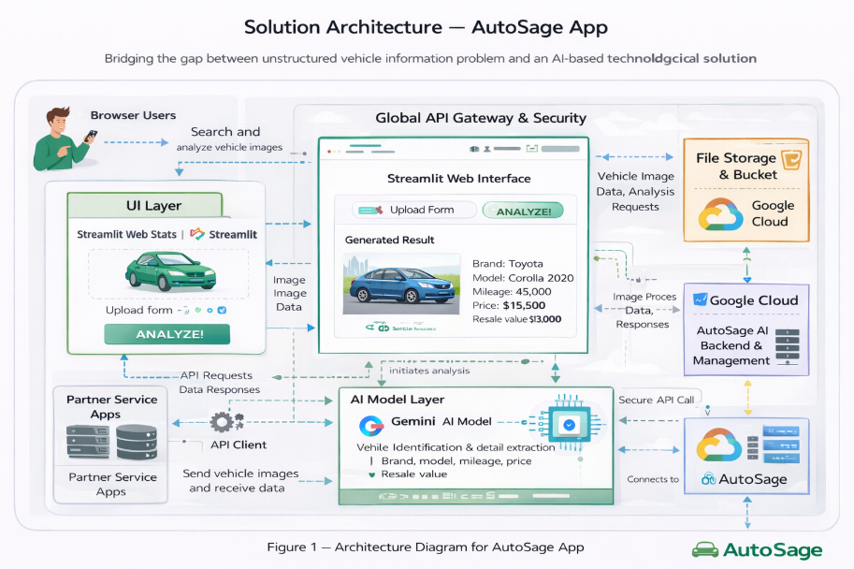**Solution Architecture Diagram:**

**5. PROJECT PLANNING & SCHEDULING**

**5.1. Project Planning**

**Product Backlog, Sprint Schedule, and Estimation (4 Marks)**

**Product Backlog, Sprint Schedule, and Estimation (4 Marks)**

The following table outlines the **product backlog items** and their allocation across different sprints for the AutoSage project.

|  |  |  |  |  |  |  |  |  |
| --- | --- | --- | --- | --- | --- | --- | --- | --- |
| **Sprint** | **Functional Requirement (Epic)** | **User Story No.** | **User Story / Task** | **Story Points** | **Priority** | **Team Members** | **Sprint Start Date** | **Sprint End Date (Planned)** |
| **Sprint-1** | UI Development | US-1 | As a user, I want a simple Streamlit interface to upload vehicle images. | 2 | High | All Team Members | 28 Jan 2026 | 31 Jan 2026 |
| **Sprint-1** | Image Format Validation | US-2 | As a user, I want the system to accept only supported image formats. | 1 | High | All Team Members | 28 Jan 2026 | 31 Jan 2026 |
| **Sprint-2** | AI Integration | US-3 | As a user, I want my vehicle image to be analyzed using the Gemini Flash AI model. | 3 | High | All Team Members | 02 Feb 2026 | 09 Feb 2026 |
| **Sprint-2** | Prompt Design | US-4 | As a user, I want the system to generate structured vehicle information automatically. | 2 | High | All Team Members | 02 Feb 2026 | 09 Feb 2026 |
| **Sprint-3** | Result Visualization | US-5 | As a user, I want to clearly view the generated vehicle details on screen. | 2 | High | All Team Members | 12 Feb 2026 | 18 Feb 2026 |
| **Sprint-3** | Application Deployment | US-6 | As a user, I want the AutoSage app to be accessible via a web browser. | 2 | Medium | All Team Members | 12 Feb 2026 | 18 Feb 2026 |

**Project Tracker, Velocity & Burndown Chart: (4 Marks)**

| **Sprint** | **Total Story Points** | **Duration** | **Sprint Start Date** | **Sprint End Date (Planned)** | **Story Points Completed (as on Planned End Date)** | **Sprint Release Date (Actual)** |
| --- | --- | --- | --- | --- | --- | --- |
| Sprint 1 | 20 | 4 Days | 28 January 2026 | 31 January 2026 | 20 | 31 January 2026 |
| Sprint 1 | 20 | 4 Days | 28 January 2026 | 31 January 2026 | 20 | 31 January 2026 |
| Sprint 1 | 20 | 4 Days | 28 January 2026 | 31 January 2026 | 20 | 31 January 2026 |
| Sprint 2 | 20 | 8 Days | 02 February 2026 | 09 February 2026 | 20 | 09 February 2026 |
| Sprint 2 | 20 | 8 Days | 02 February 2026 | 09 February 2026 | 20 | 09 February 2026 |
| Sprint 3 | 20 | 7 Days | 12 February 2026 | 18 February 2026 | 20 | 18 February 2026 |
| Sprint 3 | 20 | 7 Days | 12 February 2026 | 18 February 2026 | 20 | 18 February 2026 |

**Velocity Calculation**

Velocity represents the number of story points completed in a sprint.

Assuming a **10-day sprint cycle**, the team consistently completed **20 story points per sprint**.

Average Velocity (AV)  
= Total Story Points Completed ÷ Sprint Duration  
= 20 ÷ 10  
= **2 story points per day**

This indicates a **stable and predictable development pace**, enabling effective sprint planning and delivery for the AutoSage project.

**6. FUNCTIONAL AND PERFORMANCE TESTING**

**6.1 Performance Testing**

## **Test Scenarios & Results**

|  |  |  |  |  |  |
| --- | --- | --- | --- | --- | --- |
| **Test Case ID** | **Scenario (What to test)** | **Test Steps (How to test)** | **Expected Result** | **Actual Result** | **Pass/Fail** |
| FT-01 | Image Upload Validation | Upload valid image formats (JPG, PNG) and invalid formats (PDF, TXT) | Valid images should be accepted and invalid formats rejected with error message | System accepted valid images and rejected invalid formats correctly | Pass |
| FT-02 | Image Size Validation | Upload an image exceeding the defined size limit | System should restrict large images or process them without crashing | System handled large images without crashing | Pass |
| FT-03 | Vehicle Analysis Generation | Upload a vehicle image and click the analyze button | Vehicle details such as brand, model, mileage, and price should be generated | Vehicle information was generated correctly | Pass |
| FT-04 | API Connection Check | Test with valid and invalid Gemini Flash API keys | Valid key should connect successfully; invalid key should show error | API connected successfully and showed error for invalid key | Pass |
| FT-05 | Output Display Validation | Verify clarity and structure of generated results | Output should be readable and well-structured | Output displayed in organized format | Pass |
| PT-01 | Response Time Test | Upload an image and measure processing time | Response time should be within 5 seconds | Response generated within acceptable time | Pass |
| PT-02 | Multiple Request Handling | Upload multiple images sequentially | Application should handle repeated requests without freezing | System processed requests smoothly | Pass |

**6.2 User Acceptance Testing (UAT)**

The purpose of this document is to describe the test coverage, defect status, and user acceptance results of the **AutoSage App** at the time of release for User Acceptance Testing (UAT). It confirms that the application meets functional and performance expectations before final deployment.

**Defect Analysis**

|  |  |  |  |  |  |
| --- | --- | --- | --- | --- | --- |
| **Resolution** | **Severity 1** | **Severity 2** | **Severity 3** | **Severity 4** | **Subtotal** |
| **Fixed** | 2 | 1 | 1 | 0 | 4 |
| **Duplicate** | 0 | 0 | 1 | 0 | 1 |
| **Not Reproduced** | 0 | 0 | 1 | 0 | 1 |
| **By Design** | 0 | 1 | 0 | 0 | 1 |
| **Totals** | 2 | 2 | 3 | 0 | 7 |

**Test Case Analysis Summary**

|  |  |  |  |  |
| --- | --- | --- | --- | --- |
| **Section** | **Total Cases** | **Not Tested** | **Fail** | **Pass** |
| **Image Upload Module** | 2 | 0 | 0 | 2 |
| **AI Processing Module** | 2 | 0 | 0 | 2 |
| **Output Display Module** | 1 | 0 | 0 | 1 |
| **API & Security** | 1 | 0 | 0 | 1 |
| **Performance Testing** | 1 | 0 | 0 | 1 |

**7. RESULTS**

**7.1 Output Screenshots**

The complete execution of the AutoSage application is shown in the images step by step as shown below.

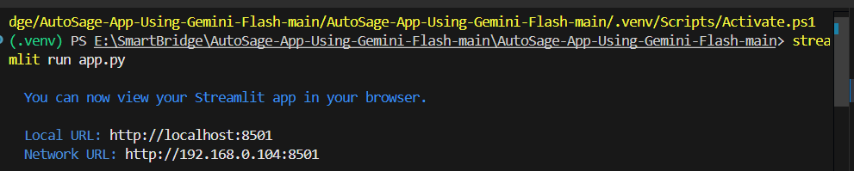**Step 1:** Run the app.py code using **streamlit run app.py** and you will get a link in terminal <http://localhost:8501> which opens automatically in the browser.

**Fig 7.1.1: Code running in Terminal**

**Step 2:** The link automatically opens to display the application.

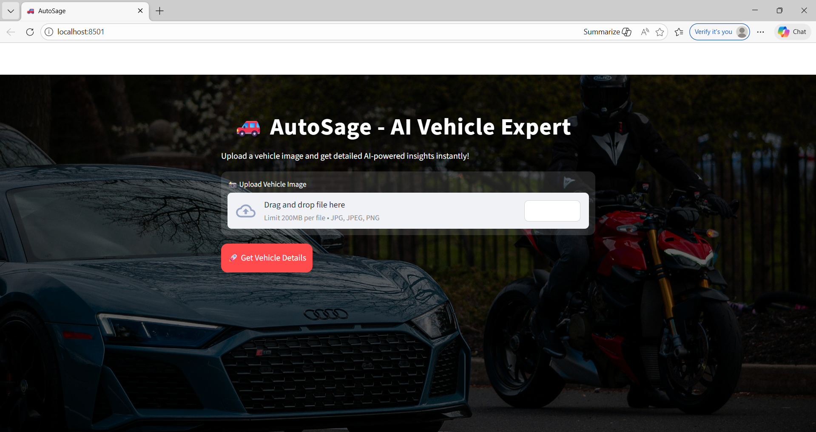

**Fig 7.1.2: AutoSage App Page**

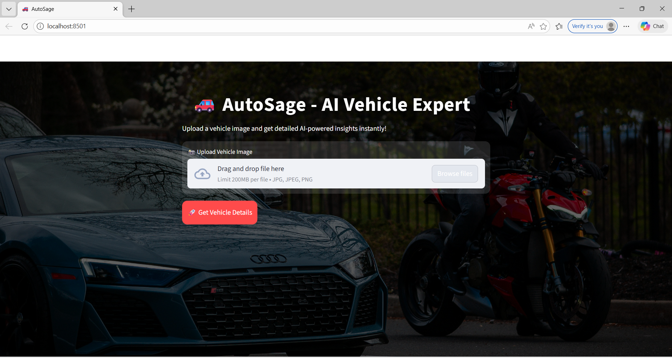**Step 3:** Click on **Browse Files** option to predict the vehicle details.

**Fig 7.1.3: Prediction Page of AutoSage App**

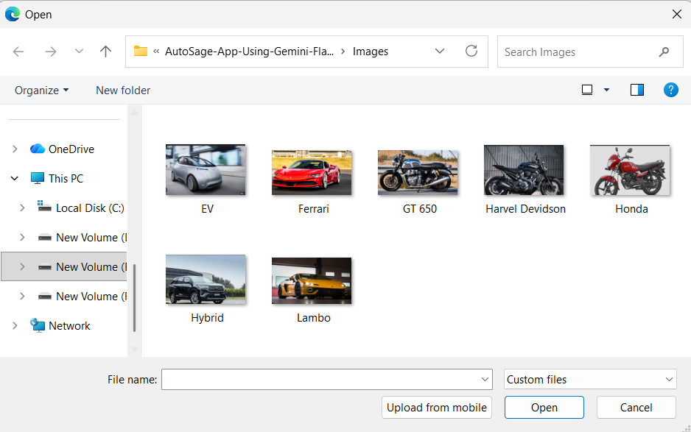**Step 4:** Click on choose file option to choose the images that need to predict.

**Fig 7.1.4: Window to choose image for prediction**

Select any image for prediction and click on Open.

**Step 5:** The image loads into the application.

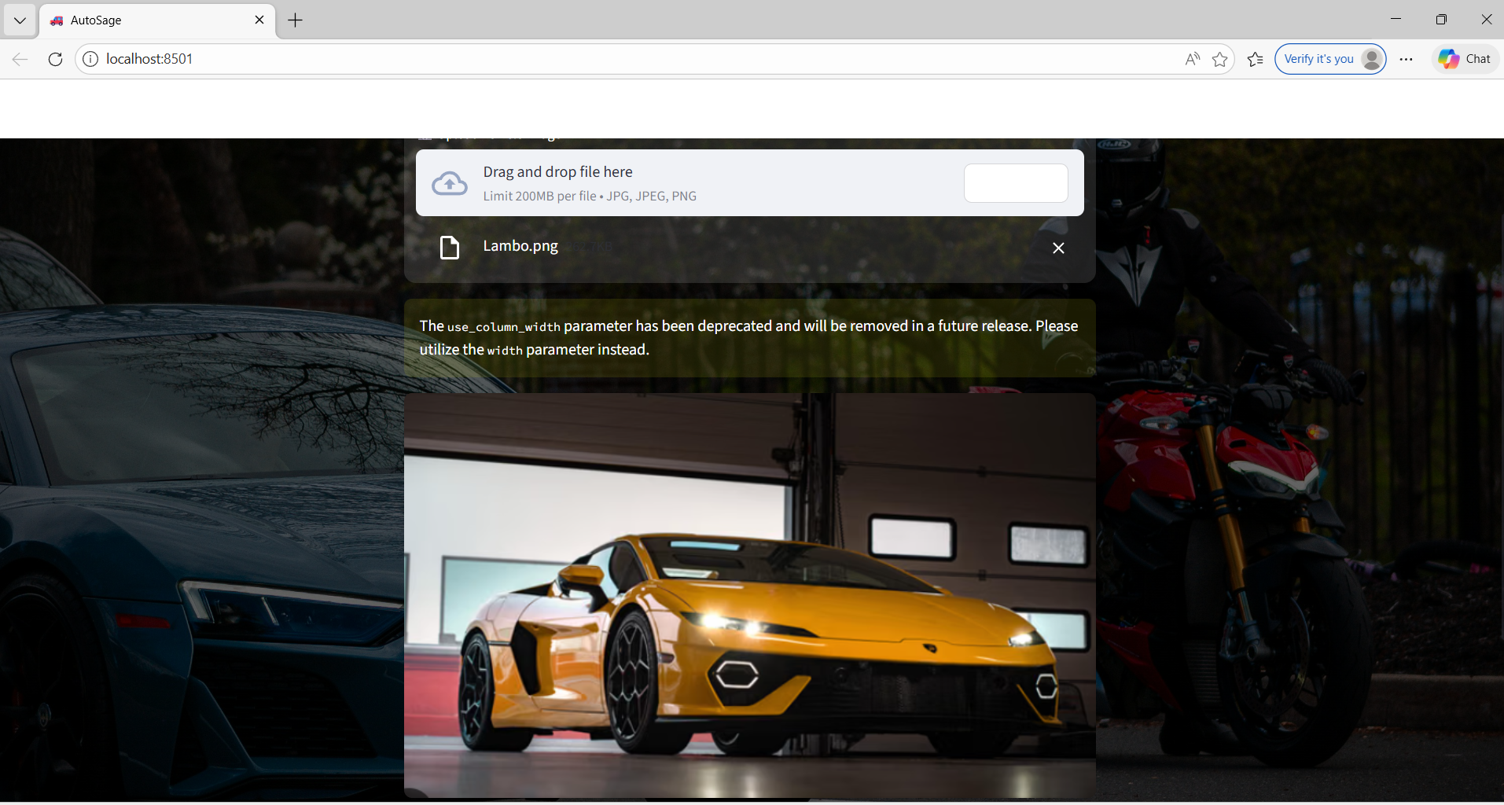

**Fig 7.1.5: Image loads into the app.**

**Step 6:** Now click on the get vehicle detailsto detect the type of vehicle and its details.

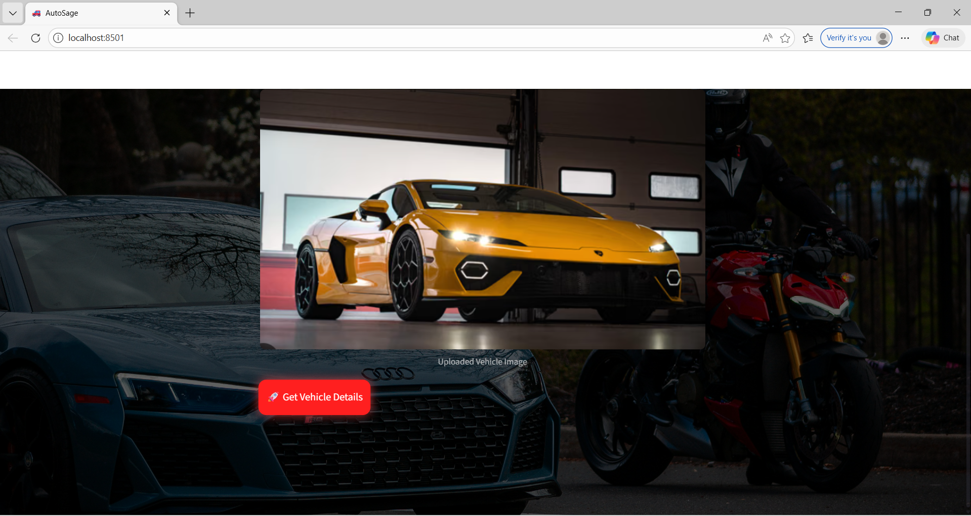

**Fig 7.1.6: Click on get vehicle details to predict**

**Step 7:** The model then predicts the type of the vehicle and provides its specifications as given below.

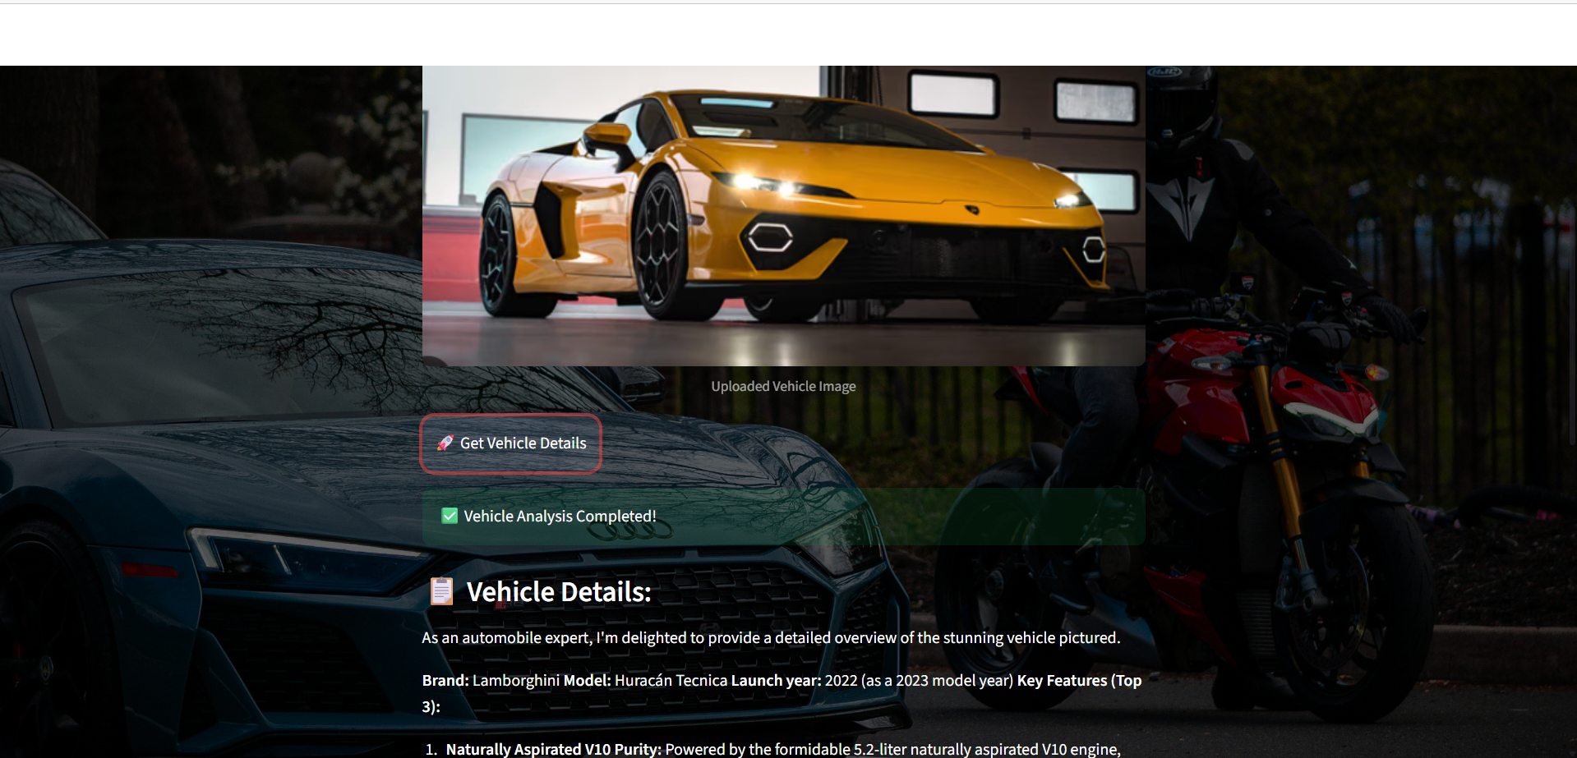

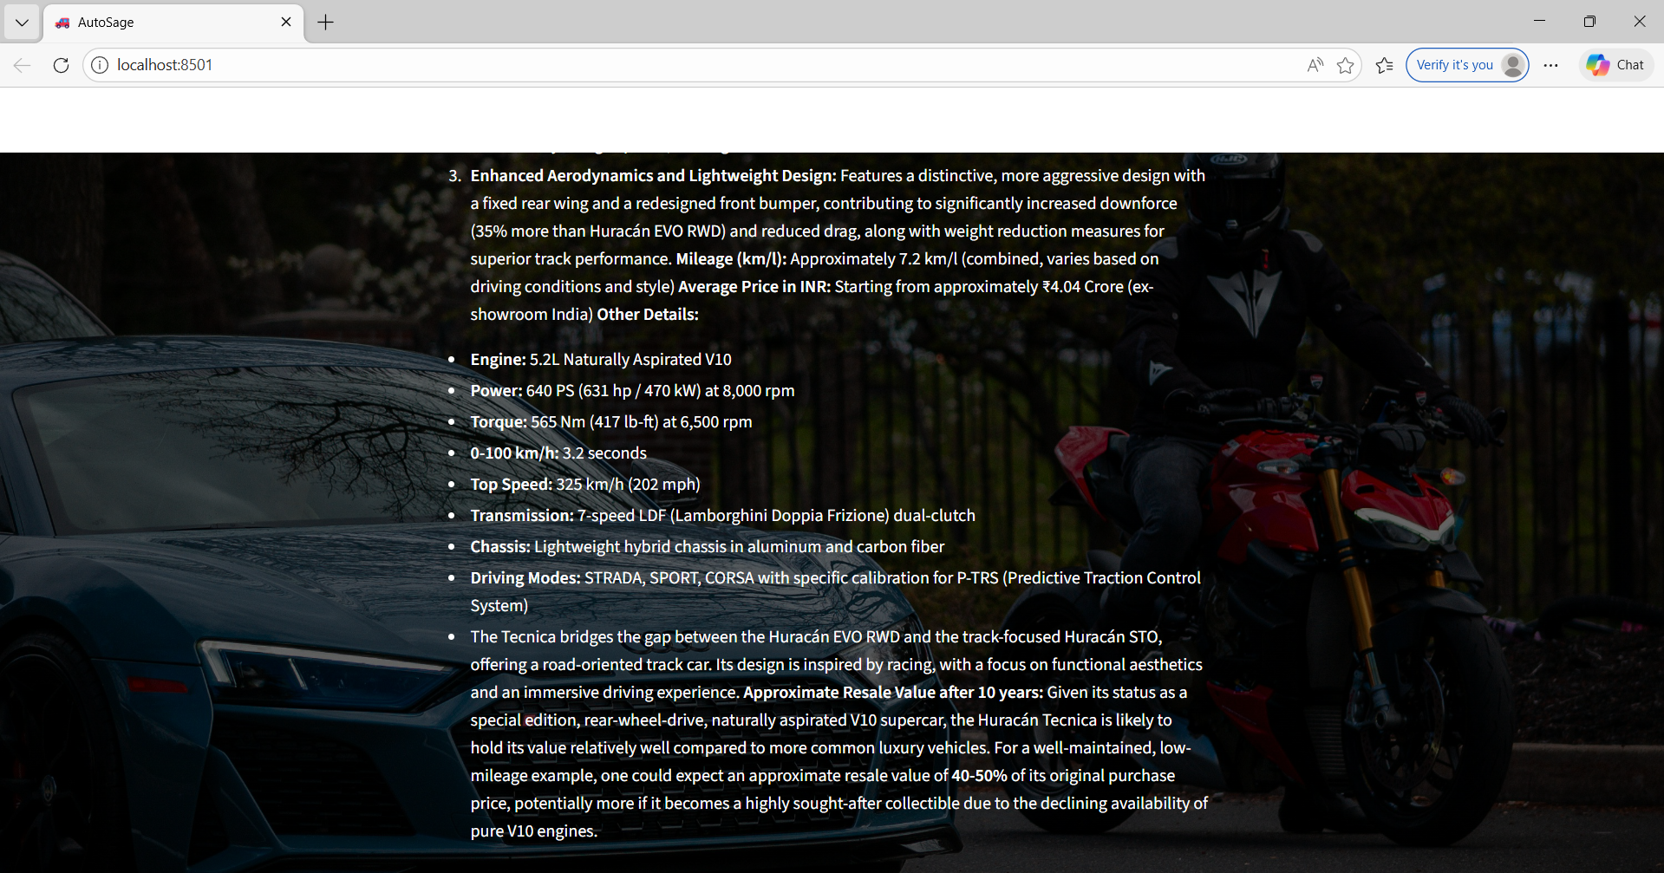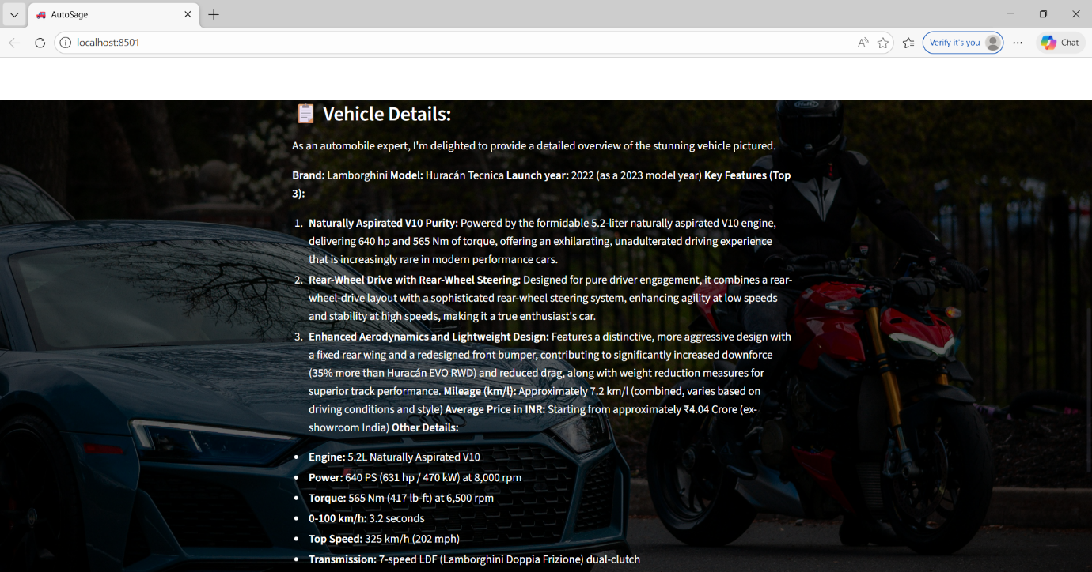

**Fig 7.1.7: Output (Details of the vechicle)**

**8. ADVANTAGES & DISADVANTAGES**

**8.1 Advantages of AutoSage Project**

|  |  |
| --- | --- |
| **Advantage** | **Description** |
| **AI-Powered Vehicle Insights** | Uses advanced AI to interpret vehicle images and convert them into meaningful, structured information automatically. |
| **Quick Analysis Output** | Provides near-instant vehicle details using a high-speed AI model, improving user efficiency. |
| **Simple & Interactive UI** | The web interface is easy to use, allowing non-technical users to upload images and view results effortlessly. |
| **Visual Intelligence Support** | Capable of understanding visual data from images, improving accuracy compared to text-only systems. |
| **Future Expandability** | Designed to easily accommodate new vehicle categories, features, and enhanced AI models. |
| **Smarter Decision Support** | Assists users in evaluating vehicles by presenting organized and reliable information. |
| **Reduces Manual Effort** | Minimizes time spent searching across platforms by delivering all key details in one place. |

**Table 8.1: Advantages**

**8.2 Disadvantages / Limitations**

|  |  |
| --- | --- |
| **Disadvantage** | **Description** |
| **Image Dependency** | Accuracy may vary if the uploaded vehicle image is blurred, poorly lit, or incomplete. |
| **Requires Internet Access** | Continuous internet connectivity is necessary for AI processing and API communication. |
| **API Usage Restrictions** | Limited API quotas may affect performance during high-volume usage. |
| **No Mechanical Diagnosis** | The system cannot identify internal engine faults or hidden physical defects. |
| **Security Responsibility** | Users must safely manage API credentials to avoid misuse or service interruptions. |

**Table 8.2: Disadvantages**

**9. CONCLUSION**

The AutoSage application effectively validates the integration of Generative AI within an intelligent vehicle information system. By leveraging the Gemini Flash multimodal model, the system processes visual vehicle inputs and converts them into structured, machine-interpretable data. The Streamlit-based frontend ensures seamless interaction between the user and the AI pipeline, while backend logic manages image preprocessing, prompt formulation, API communication, and response parsing. AutoSage demonstrates efficient use of cloud-based AI services, real-time inference, and modular architecture, making the solution scalable and adaptable. The project successfully abstracts complex AI operations into a simple user workflow, enabling rapid information retrieval without domain expertise. Furthermore, the architecture supports future extensions such as dataset-driven fine-tuning, confidence scoring, vehicle comparison modules, and integration with external automotive databases.

**10. FUTURE SCOPE**

The AutoSage system can be further enhanced by incorporating advanced AI capabilities such as fine-tuned vehicle recognition models trained on large automotive datasets to improve accuracy and reliability. Future versions may integrate real-time market data, service history insights, and predictive analytics for resale value estimation. Expanding platform support to mobile applications, enabling multilingual interfaces, and adding vehicle comparison and recommendation engines would significantly improve usability and reach. Additionally, deploying the system using scalable cloud infrastructure and introducing secure user profiles can transform AutoSage into a comprehensive AI-driven automotive intelligence platform

**11. APPENDIX**

**11.1 Source Code**

The complete source code for the **AutoSage** project is implemented using Python, Streamlit, and the Google Gemini API. The code includes modules for image upload, AI model integration, prompt handling, and output display.

**10.2 GitHub & Project Demo Link**

The source code and project demonstration video are hosted on GitHub. The repository contains all required files, including the application code, documentation, and setup instructions.

* **GitHub Repository:**

<https://github.com/poojitha-kanipakam/AutoSage-App-Using-Gemini-Flash>

* **Project Demo Video:** <https://drive.google.com/file/d/1lkRipbCoJDrS6wHaYOm9zvks7mXQVzIQ/view?usp=sharing>